**Unit 6**　**In a Nature Park**

**Part B** (**3**)

词汇 积累练

一、写出下列单词的复数形式并选出相应的图片。(24分)

(　　)1.cloud__________ (　　)2.path__________

(　　)3.city__________ (　　)4.holiday__________

(　　)5.house__________ (　　)6.road__________

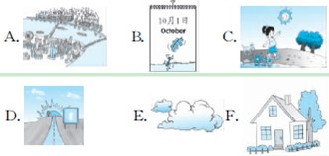

语句 应用练

二、根据图片提示，选词填空。(30分)

(　　)1.This is my ________.

(　　)2.There're some ________ in it.

(　　)3.There's a ________ over the river.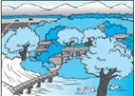

(　　)4.There are some ______ on the river.

(　　)5.—What's on the ________？

—Cars.

QQ截图20121206110201

三、补全对话。(30分)

A：Look！This is a photo of my hometown(家乡)．

B：________there any bridges________your village?

A：________，there are.

B：________there any tall buildings________your village?

A：________，there aren't.

B：It's beautiful.

阅读 理解练

四、阅读对话，选择正确的答案。(16分)

Mike：I like my village.There are many rivers in the village.There are many trees near the rivers.The water is clean.The air is fresh.

Wu Yifan：I like my village，too.There are many mountains near my village.There are no tall buildings.There are only small houses.The sky is blue.The clouds are white.

Mike：Are there any flowers?

Wu Yifan：Yes, there are many flowers, and I can run on the grass.

(　　)1.Which picture is Wu Yifan's village?

A.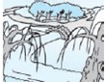　 B. 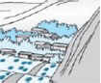

(　　)2.There are no ________ in Wu Yifan's village.

A．tall buildings　　　　 B．houses

(　　)3.The clouds are ________ in Wu Yifan's village.

A．white B．grey

(　　)4.—Are there any trees near the rivers in Mike's village?

—________

A．Yes, there are. B．No, there aren't.

**答案详解**

一、1.E　clouds　2.C　paths　3.A　cities 4．B　holidays　5.F　houses　6.D　roads

二、1.B　2.D　3.A　4.E　5.C

三、Are，in，Yes，Are，in，No

四、1.B　2.A　3.A　4.A